ICT LAB PROJECT

**Title:** Restaurant Website

**Group mates:**

* Hamza Irshad **Roll#:** 232464
* Abdullah Jamil  **Roll#:** 232425

**Project:** Rich Cuisine Restaurant

**Purpose:** Our Rich Cuisine Restaurant project is a tasty journey. We want to show off our cooking skills and create a fun online experience. The goal is to make a website that looks good and is easy for everyone to use. We want it to reflect the warmth of our restaurant and the delicious food we offer.

**Target Audience:** This project is for food lovers! Whether you're looking for a cozy place to eat or celebrating something special with friends and family, we've got something for you. It's for anyone who enjoys good food and a friendly atmosphere.

**Requirements:** To make our project awesome, we used HTML for structure and CSS for style. This ensures a simple and easy-to-use design.

HTML and CSS Implementation:

**Home:** The Home page introduces you to Rich Cuisine with pictures of our tasty dishes and desserts.

**About:** Learn about us! Find out about Rich Cuisine branches in different cities for an authentic touch.

**Menu:** Explore our Menu with a variety of appetizers, main courses, and desserts.

**Gallery:** Take a peek at our restaurant through pictures of the cozy atmosphere and tempting dishes.

**Contact:** Reach out to us easily through the Contact page. We've provided all the details and links to our social media for quick communication.

**Reservation:** Book a table hassle-free, whether it's a quiet dinner or a lively group celebration.

Our Aim: We want to present a website that's easy to use and looks great – a true reflection of Rich Cuisine. Our hope is to impress not only our teacher but also everyone who visits our virtual culinary haven. Come and explore the world of Rich Cuisine

**Our Aim:** We aspire to deliver a website that's user-friendly, visually appealing, and truly embodies the essence of Rich Cuisine. Our goal is to provide an outstanding online experience for all visitors to our virtual culinary haven. Come and explore the world of Rich Cuisine, where we strive to offer top-notch service!

**HOME**

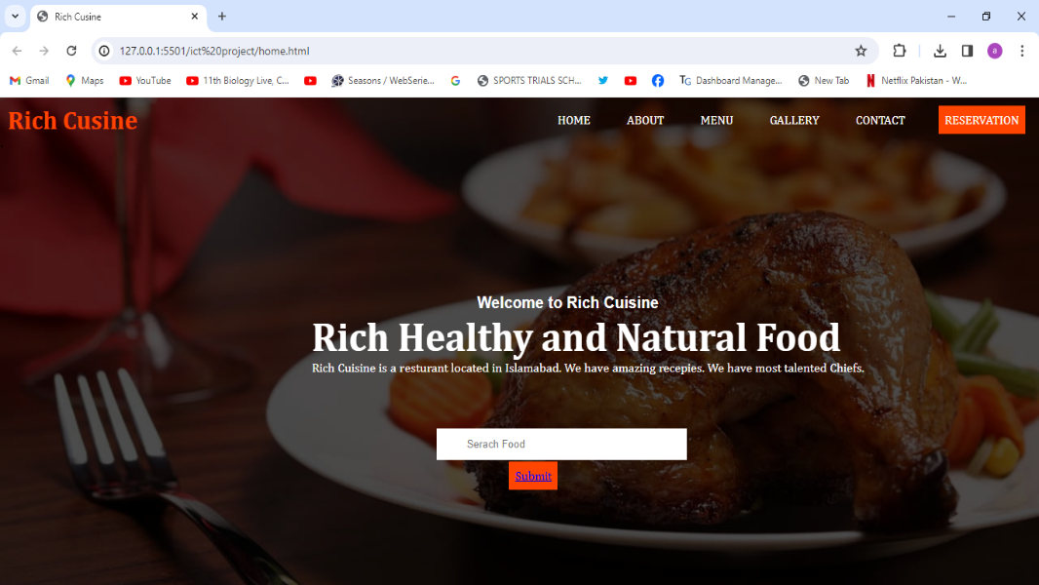

**ABOUT**

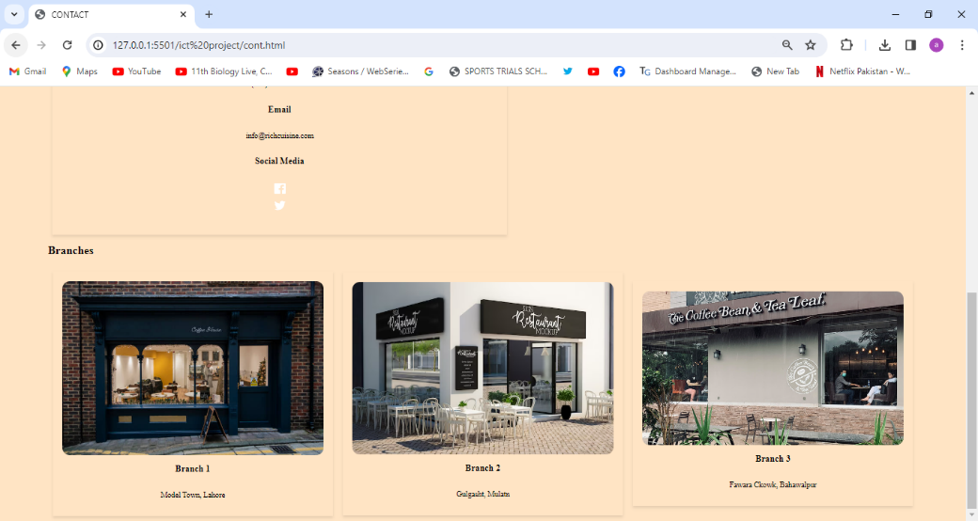

**MENU**

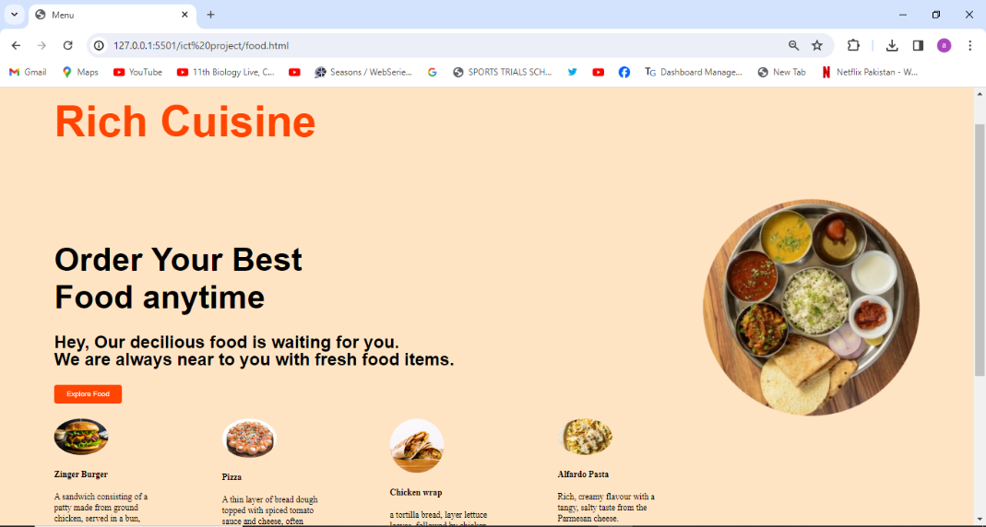

**GALLERY**

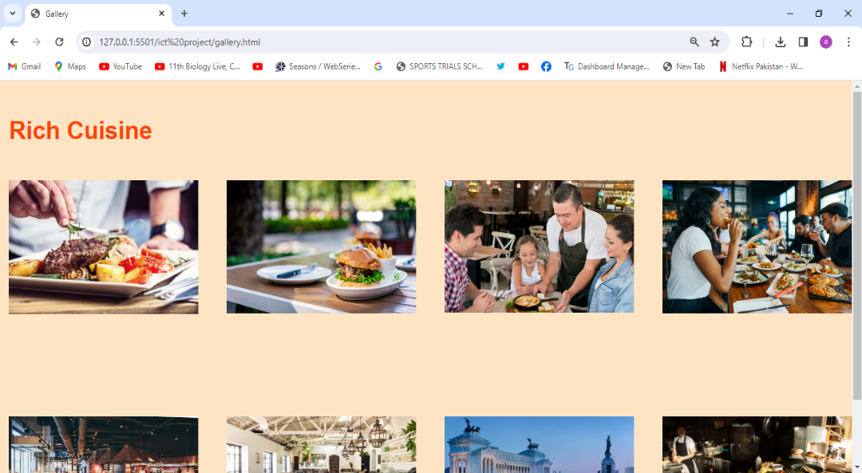

**CONTACT**

